Computer Science Jeroo Lab 03B – Pinball’s Journey Lab Value - 100

Lab Goal : To analyze a problem and determine the methods needed to solve it. You must plan each method based on preconditions as well as post conditions. When finished, Pinball will be at the bottom of the island with all flowers removed.

Lab Description: Create two methods that would allow Pinball to pick all flowers and come to a stop before jumping off the island into the water. Pinball must avoid the water and must not miss a space in picking every flower.
Files Needed ::
Jeroo_Lab3B.jsc
Pinball_Island.jev

Sample Output :

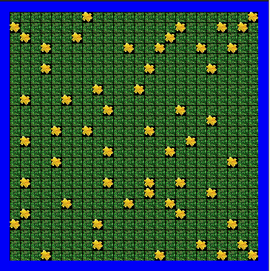
algorithm help

Analyze – what tasks do I need to do.

What must each method accomplish?

Do I need loops?

Do I need ifs to make decisions?

Do I need to make methods?

Preconditions –
- Jeroo will start at 0,0
- Jeroo will be facing EAST

Postcondition –
- Flowers are completely gone.
- Jeroo stops without jumping in the water.



